加载jar这一部分很容易，可是卸载jar就没那么容易了。加载jar的时候需要用反射去调用URLClassLoader的addURL方法。Tomcat的StandardClassLoader继承于URLClassLoader。

<%@ page language="java" pageEncoding="UTF-8"%>

<%@ page import="java.util.*"%>

<%@page import="java.net.URL"%>

<%@page import="java.lang.reflect.Method"%>

<%@page import="java.net.URLClassLoader"%>

<%

    URLClassLoader c = (URLClassLoader) getClass().getClassLoader().getParent().getParent();

    URL jar = new URL("<http://javaweb.org/jars.jar>");

    try {

        Method m = URLClassLoader.class.getDeclaredMethod("addURL", URL.class);

        m.setAccessible(true);

        m.invoke(c,new Object[]{jar});

        URL[] url = c.getURLs();

        for(URL u:url){

            out.println(u+"<br/>");

        }

        Class<?> test = Class.forName("com.javaweb.test.Test");

        Method method = test.getDeclaredMethod("test",HttpServletRequest.class);

        Object obj = method.invoke(test.newInstance(), new Object[]{request});

        out.println(method.getName()+":"+obj);

    }catch(Exception e){

        e.printStackTrace();

    }

%>

jars.jar内容：

package com.javaweb.test;

import javax.servlet.http.HttpServletRequest;

public class Test{

    public String test(HttpServletRequest request){

        String str = request.getSession().getServletContext().getRealPath("/");

        System.out.println(str);

        return str;

    }

}

输出：

[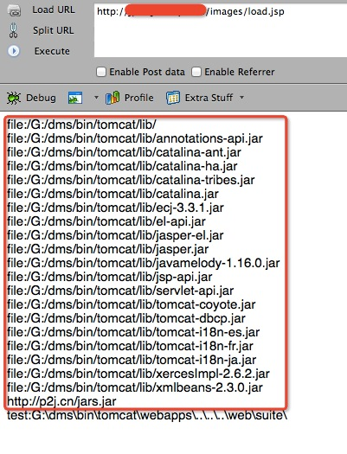](http://javaweb.org/wp-content/uploads/2014/05/11.jpg)